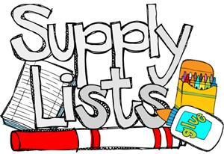

Second Grade

|  |  |
| --- | --- |
| * Back pack (NO WHEELS) * Water bottle * 2 boxes of tissues * 2 bottles of antibacterial soap * 2 Lysol Wipes * 2 bottles of hand sanitizer * 1 pack of EXPO markers * 1 pencil box or pencil pouch * 1 box of crayons * 2 packs of pencils * 2 large erasers * 1 pair of children scissors * 1 pack of ELMER glue sticks * 1 packs of post-its * 3 composition books * 1 1/2 inch 3-ring binder * 1 1 inch 3 ring binder * 1 pack of copy paper * **Headphones** | **Spirit Shirts available for sale in the office or online for 10.00 each.** |